Innovation # 888
Enhanced Lab Order Menu
Contract # VA118-11-D-1000
Task Order # VA118-1000-0030

Release Notes
Version 1.0



Prepared by:

Systems Made Simple, Inc.
149 Northern Concourse
Syracuse, NY 13212

April 2015

Date | Version | Description | Author
04/30/2015 | 1.0 | Final document | Geoff Hunter

1 Introduction 2
1.1 Purpose 2
1.2 Scope 2
1.3 Assumptions and Dependencies 2
1.4 Acronyms and Definitions 3
2 Release changes 4
2.1 Bug fixes 4
2.2 Known issues 4
2.3 Remaining items 4
3 Approval Signatures 6

Introduction
This Enhanced Lab Order Menu Test Configuration guide is presented by Systems Made Simple (SMS) to the Department of Veterans Affairs (VA). This deliverable and its solutions are required per the contract.
Veterans Health Administration (VHA) management has embraced the principle of innovation to determine areas for possible improvements in the current Veterans’ health care system. These innovations along with the move to modernize the CPRS system to the new enterprise Health Management Platform (eHMP) will streamline the process for Veterans’ patient care.
The Enhanced Lab Order Menu project was established with the following primary goals:
- To combine multiple independent menu items to a single screen.
- To improve the workflow and reduce the time spent on ordering lab tests for patients.
- To increase the size of the General Ward Instruction box to eliminate the need for scrolling thru multiple lines of instructions.
- To highlight the Turnaround time to decrease the possibility of ordering tests that will not return results in a timely manner.
This document describes the release notes for the software.

Purpose
The purpose of this document is to provide a detailed description of changes since the previous
release, bug fixes, known issues, and a manifest of remaining items to complete the project for the Enhanced Lab Order Menu (ELOM) software.

The installation described in this document is for a standalone instance of the software, not the ELOM software integrated into the eHMP application.

Scope
The scope of information in this document is for the preparation of the platform that will run all elements of the ELOM software (e.g., database, and web application) to yield an operational system. This document will be kept current for the software produced in each sprint of the development cycle.
This plan assumes baseline Virtual Machines (VMs) have been created with the appropriate Operating System (OS) (e.g., Red Hat Enterprise Server, 64-bit) and application software (e.g., Oracle WebLogic, VistA database, and so on). The instructions in this plan deal with the configuration of the baseline VM and the deployment of the ELOM application.
All continued customizations is based on Government selected prioritization and the ability to change and release new documentation must be executed in accordance with an agile methodology. SMS shall continue to provide information and training to the VHA trainers so that the information can be used to train and communicate with the end users.

Assumptions and Dependencies
Users of this document are assumed to have a working knowledge of the target platform OSs and their native editors (for example, vi), and the COTS software applications used by the application.

Acronyms and Definitions
Through the life of the project, SMS will follow the prevailing use of acronyms within the VA, many of which are published on the VA Information Resource Center Acronym Lookup and Glossary.

Table 1: Acronyms
Term | Definition
API | Application Programming Interface
COTS | Commercial-off-the-Shelf
CSS | Cascading Style Sheet
DB | Database
FTP | File Transfer Protocol
FTPS | File Transfer Protocol-Secure
HTML | Hyper Text Markup Language
HTTP | HyperText Transfer Protocol
ID | Identification
IE | Internet Explorer
IP | Internet Protocol
OS | Operating System
SCP | Secure Copy
SFTP | SSH File Transfer Protocol
SMS | Systems Made Simple, Inc.
SQA | Software Quality Assurance
SSH | Secure Shell
SSL | Secure Socket Layer
UAT | User Acceptance Testing
URL | Uniform Resource Locator
VA | Department of Veterans Affairs
VHA | Veterans Health Administration
VM | Virtual Machine
VPN | Virtual Private Network

Release changes

Bug fixes
No known bugs to be fixed in the software at the time of the release.

Known issues
Based on the requirements available for location of data fields, assumptions were made based on the data in the developer Vista database.

Remaining items
The purpose of this section is to provide a detailed manifest of the remaining items to complete the project for the Enhanced Lab Order Menu (ELOM) software.

List of items:
- Specimen default data location
- Collection type default data location
- How Often default data location
- How long default data location
- Location for Saved lab order data

It should be an easy mapping exercise to add the four default locations to the software. The lab orders are currently being saved to a temporary location in the database and this can be mapped to the correct location in the database once this has been determined.

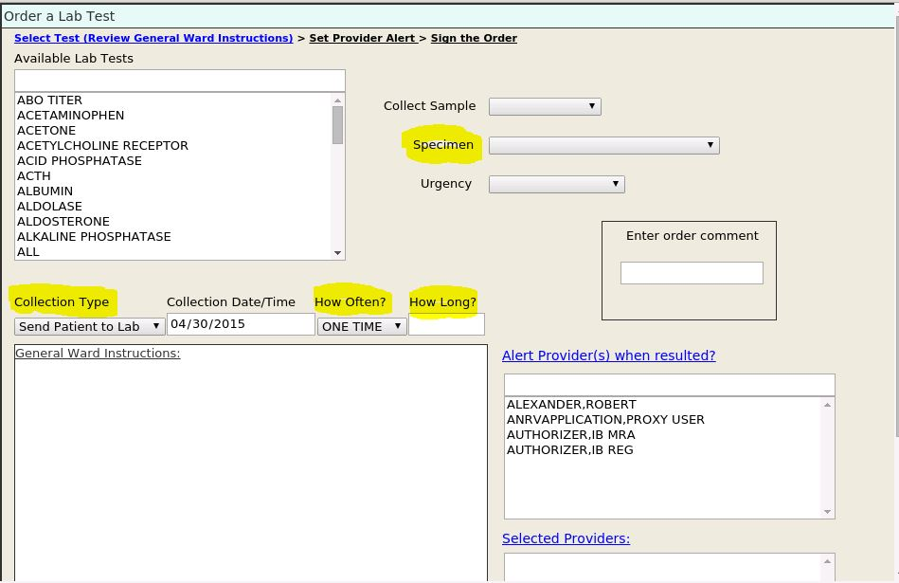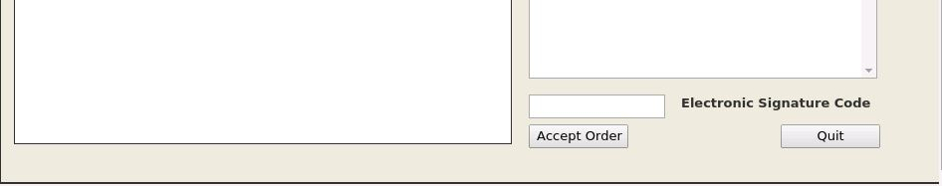
Enhanced Lab Order Menu screen

Approval Signatures
This section is used to document the approval of the Innovation #888 Enhanced Lab Order Menu Release Notes during the Formal Review. The review should be conducted face to face where signatures can be obtained “live” during the review.
If unable to conduct a face-to-face meeting then it should be held via LiveMeeting and concurrence captured during the meeting. The Scribe should add /es/name by each position cited.
Please annotate signature blocks accordingly.

Version: | DRAFT
Review Date: | <MM/DD/YYYY>
Scribe: | <Name>
<NAME> |  | Date:
Program Manager
<NAME> |  | Date:
Contract Officer’s Representative

